From: https://medium.com/@caityjohnstone/shut-the-fuck-up-john-bolton-6bdb4334f29c
Caitlin Johnstone
Rogue Journalist
Aug 4

Shut The Fuck Up, John Bolton
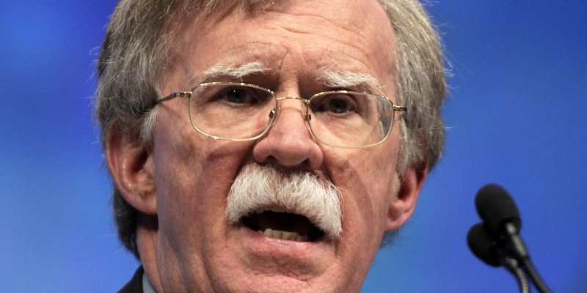
Bloodthirsty neocon John Bolton has written an essay for the Wall Street Journal advocating regime change in North Korea just one day after advocating for regime change in Venezuela, and it’s time for him to shut the fuck up.
Bolton, who is a PNAC signatory and senior fellow at America’s top neoconservative think tank American Enterprise Institute, told theWashington Examiner that he still believed the US invasion of Iraq was the right decision. Not in 2004, not in 2005, but in 2015. He’d sound less psychotic if he’d accidentally shaved off half his mustache in 2003 and kept it that way for the next twelve years just so he could claim he’d done it on purpose.
“I still think the decision to overthrow Saddam was correct. I think decisions made after that decision were wrong, although I think the worst decision made after that was the 2011 decision to withdraw U.S. and coalition forces,” Bolton said. “The people who say, oh things would have been much better if you didn’t overthrow Saddam miss the point that today’s Middle East does not flow totally and unchangeably from the decision to overthrow Saddam alone.”
Bolton also told the Washington Post that, if he could go back in time and take control of the situation knowing everything he knows now, he would still choose to invade Iraq and depose Saddam Hussein. Knowing everything he knows now. Knowing how many hundreds of thousands of Iraqi lives it cost, knowing how many thousands of American lives it cost, knowing there were no WMDs, knowing how it would destabilize the region, knowing how long and costly a military operation it would be.
That’s like Steve Harvey saying that if he had it all to do over again, he’d still give the Miss Universe crown to Miss Colombia.
This unrepentant psychopath has had his evil fingers deep in the guts of US foreign policy for decades now, and he is horrifyingly being discussed as a possible replacement for HR McMaster as National Security Advisor to the President. He has been completely wrong about everything and the world would unquestionably be better off if he’d never been born, but you routinely see this asshole as a guest on Fox News like he’s a guy who knows stuff.
Shut the fuck up, John Bolton. You are horrible and your lies kill people. You don’t make the world a better place, you make it a far, far worse place. Go lie down and curl up in a ball where you can’t do any more harm and wait for death, since you love it so much. Shut the fuck up. You don’t know anything. Stop poisoning people with your disgusting mind viruses. Your ideas are bad and you should feel bad.
US regime change is always worse than the government it topples. This is because America is itself a profoundly sick regime, so the cure isn’t just worse than the disease — it is disease itself. It is impossible for America to use force to impose its will upon a sovereign nation without creating evil, because the US war machine is itself evil, and what it does is evil. If any other country behaved the way America behaves, America would’ve invaded it and installed a puppet government ages ago.
And that’s all I have to say about John Bolton for the moment. Please be sure to take some time out of your day — perhaps every day — to tell John Bolton to shut the fuck up. Thank you.
— — —

